Tokenizing CO2 certificates and

Creating Digital Marketplace

**Team Members**

Gurpreet Singh Sodhi

Shahan Ahmed

Nicole Mann

Etan Winograd

**Project Description / outline**

The Paris Agreement is a landmark international accord that was adopted by nearly every nation in 2015 to address climate change and its negative impacts. The agreement aims to substantially reduce global greenhouse gas emissions in an effort to limit the global temperature increase in this century to 2 degrees Celsius above preindustrial levels, while pursuing the means to limit the increase to 1.5 degrees.

More than 200 countries have signed the Paris Climate Agreement. However, enacting and implementing the laws to meet the Accord requirements is the biggest hurdle. There is no standard mechanism of allocating Carbon certificates. In addition, this market lacks a secondary trading marketplace where companies with excess carbon certificates can sell to deficit companies. Lack of an efficient market has disincentivized the participants to be more efficient.

CO2 TokenEx – Our team has solved both the critical issues with this project. The project is a combination of smart contract written in Solidity and a web based front end, that interacts with the smart contract on the Ethereum chain.

Smart contract can only be deployed by authorized government (e.g. US Treasury). Once a contract is deployed, the owner I.e. US Treasury will tokenize carbon certificates and allocate it to the major carbon producers.

In addition, a digital market place is created to encourage carbon producers to minimize their carbon footprint and produce less than allocated quota. The companies with excess Carbon tokens can sell in the market place and offer a certain price in Ethers. The deficit companies can buy from the cheapest source, hence creating efficiencies in the secondary market. All of this functionality is coded using Solidity.

**Research questions to answer**

We want to create an efficient digital market for buying and selling Carbon tokens. These carbon certificates will be tokenized (I.e minted) on the same chain using Smart contract concepts.

**Rough breakdown of tasks**

All team members will participate in various tasks. However, below is the list of team members with their primary responsibility

Framework design / Solidity code Gurpreet Singh Sodhi

Research / Powerpoint Etan Winograd

Web interface / Integration Shahan Ahmed

Solidity code / Research Nicole Mann

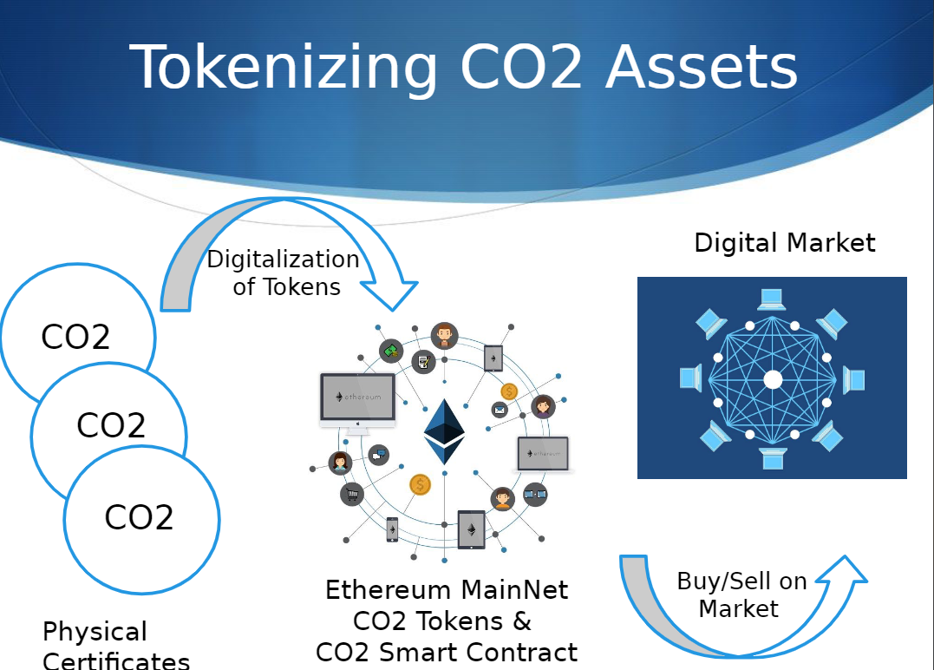

**Github** : <https://github.com/gurpreetsodhi/Columbia_Fintech_Project3>